### AY2016 Semester 2

|  |  |  |  |
| --- | --- | --- | --- |
| Name |  | | |
| Student ID |  | | |
| Assessment Venue |  | Seat Number |  |

**E356 ESE**



E356: PHARMACEUTICAL AND BIO-CHEM SUPPLY CHAIN

**AY2016 Semester 2 End-Semester Examination (ESE)**

|  |  |  |
| --- | --- | --- |
| ***This segment is to be used by staff grader(s) only.*** | | |
| **Question Number** | **Marks Awarded** | **Max Marks** |
| **1** |  | **11** |
| **2** |  | **31** |
| **3** |  | **26** |
| **4** |  | **22** |
| **5** |  | **10** |
|  |  |  |
|  |  |  |
|  |  |  |
|  |  |  |
|  |  |  |
|  |  |  |
|  |  |  |
|  |  |  |
|  |  |  |
|  |  |  |
|  |  |  |
|  |  |  |
|  |  |  |
|  |  |  |
| **Total** |  | **100** |

|  |  |
| --- | --- |
| **Instructions to student:** | |
| 1) | Do not turn over this question paper until you are instructed to do so by the invigilator. |
| 2) | Write your name, student ID, assessment venue and seat number in the table provided at the top of each page. |
| 3) | For this question paper, there are **17** pages (including this cover page). |
| 4) | For this assessment, you are allowed to:   * Refer to materials stored in your laptop. * Have a blank piece of paper for rough working purpose. (Note that the sheet of rough working paper will not be accepted for submission at the end of the assessment.) |
| 5) | For this assessment, you are **NOT** allowed to:   * Refer to written materials including textbooks and hardcopy notes. * Share any material, such as calculators, with another student. * Communicate with any person other than the invigilator. * Use any communication devices such as handphone or smart watches while at the assessment venue. |
| 6) | All rules and regulations pertaining to summative assessments and academic integrity stated in the Student Handbook shall also apply. |

|  |  |  |
| --- | --- | --- |
| ***This segment is to be used by the invigilator only.*** | | |
| Please tick the box below if the student has done part of the assessment online: | Invigilator’s Name: | Invigilator’s Signature: |
| Partially done online |  |  |

Page 1 of 17

**QUESTION 1 [11 Marks]**

1. Fill in the blanks a), b), c), d), and e):

In Singapore, (a) is a guide or standard that those companies involved in the storage, transportation and distribution of medicinal products must conform to, while (b) is a guide or standard that all manufacturers and assemblers of medicinal products are required to conform to.

(c) is the regulatory authority that would conduct audits on medicinal product manufacturers and assemblers based on the required guide or standard in Singapore. According to the required guides or standards, (d) areas should be provided for the storage of rejected, recalled or returned materials or products.

Adding instructions insert is one of value-added services, which take places in the (e) manufacturing.

(5 marks)

1. For the pharmaceutical products shown below, identify the pharmaceutical form that it is in and the type of consumer packaging used by filling in the blanks a), b), c), d), e) and f) in Table1.1.

(6 marks)

You may select your answers from the list below.

|  |  |
| --- | --- |
| **Pharmaceutical form**   * Gel capsule * Capsule * Orally Disintegrating Tablet * Tablet * Syrup * Powder * Inhalation * Cream * Gel * Eye Drop * Spray * Injection / Intravenous * Suppository | **Consumer Packaging**   * Blister * Bottle * Tube * Sachet * Vial |

Table 1.1

|  |  |  |
| --- | --- | --- |
| Pharmaceutical Product | Pharmaceutical Form | Consumer Packaging |
| http://images.inmagine.com/img/imagemore/z195070/z195070055.jpg | a) | b) |
| http://us.123rf.com/400wm/400/400/mistac/mistac1203/mistac120300077/12898442-a-brown-bottle-of-pharmaceutical-pills.jpg | c) | d) |
| http://suburbanmen.com/wp-content/uploads/2011/10/needle-vaccine-syringe-vial.jpg | e) | f) |

**END OF QUESTION 1**

**QUESTION 2 [31 Marks]**

Dr Yang Lee, working in Covance Lab Services, is going to ship 45 mL of Ebola Virus packed in 10kg of Dry Ice in a UN specification package, which is placed inside an Overpack.

The information of shipper and consignee is list below:

**Shipper:** Dr Yang Lee, Covance Lab Services, 10 International Business Park, Jurong, Singapore, 609123 Tel: + 65 63718888 (24-hour contact person)

**Consignee:** Mrs Gabby, The Sants Hospital, 21 Fortune Drive, Los Angeles, 90210 U.S.A Tel: + 1 5009001300

1. Who is responsible for classifying, packing, marking, labelling and documenting the shipment? (2 marks)
2. Add the proper markings and labels for the shipment by filling in the blank A, B, C and D in the package shown in Figure 2.1, using the information given in the paragraph above. (Note: Label your answers with A,B,C and D accordingly) (4 marks)

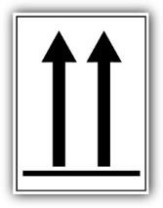



**OVERPACK**

**D**

**C**

**B**

**A**

### Figure 2.1

1. Identify suitable labels from Table 2.1 below that should be applied onto the package in Figure 2.1 above.

(2 marks)

### Table 2.1

|  |  |  |
| --- | --- | --- |
| Label 1 | Label 2 | Label 3 |

|  |  |  |
| --- | --- | --- |
| Label 4  http://www.labelsourceonline.co.uk/ProdImages/hw2200.gif | Label 5  Description: GHSHar | Label 6  Description: http://www.dreamstime.com/infectious-substance-warning-label-thumb8838745.jpg |

1. Why must the 45 mL of Ebola Virus with 10kg of Dry Ice be packed in a UN specification box? Must the Overpack be a UN specification box? (2 marks)
2. Can the package of the 45 mL of Ebola Virus with 10kg of Dry Ice be shipped by passenger aircraft? **Explain** your answer. ( 2 marks)

S

1. What is the document that must be enclosed inside the outer packaging as shown in Figure 2.1? (2 marks)
2. Where should the dry ice be placed in the package? (2 marks)
3. Prior to shipment, how do you ensure the packaging maintains its required temperature? (2 marks)
4. In Singapore, what is the governing body for Dangerous Goods transportation by air? ( 2 marks)
5. The Figure 2.2 below shows part of the dangerous goods declaration form that Dr Yang Lee has filled in. Identify and correct the mistakes made in the form. (5 marks)

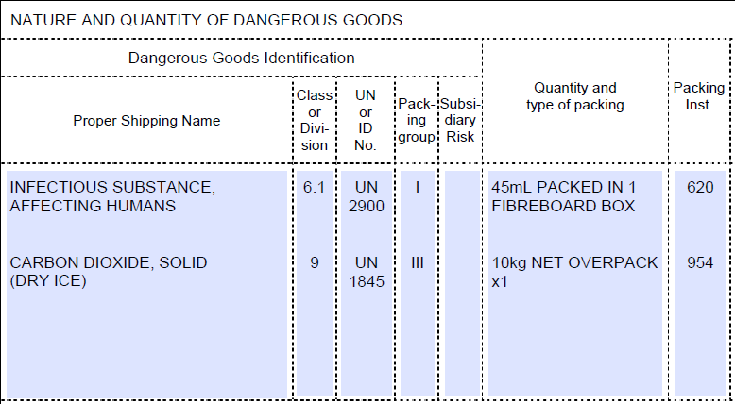

### Figure 2.2

1. Dr Yang Lee is going to engage American Airline for the shipment from Singapore to Los Angeles, U.S.A. Recommend a document/manual for him to understand the regulations of American Airline. (2 marks)
2. Dr Yang Lee finally confirmed ABC Cargo Airline to carry out the shipment. The shipment would take the routing: SIN/TPE on flight ABC11 and TPE/LAS on flight ABC22 from Singapore to Los Angeles, U.S.A.

He prepared one (1) original copy of Dangerous Good Declaration in Chinese, and made additional one (1) photocopy. After he submitted the documents to ABC Airline, he found out that the “Consignee” and “Air Waybill Number” information were written wrongly, so he quickly contacted ABC Airline and requested the Airline to amend the document on his behalf. Identify and correct **FOUR (4)** mistakes made by Dr Yang Lee. (4 marks)

## END OF QUESTION 2

**QUESTION 3 [26 Marks]**

Vincent just joined a company which is specialized in handling Dangerous Goods (DG) from import, storage to transportation in Singapore.

1. Vincent’s company is going to import and store 5000kg of **Sulphuric acid**, which is used as a cleaning agent. Name
   1. the “Act” that regulates the use of the substance;
   2. the types of license / permit you need to apply for, and
   3. the agency(s) to which you need to apply for the license/permit.

(4 marks)

1. The company needs to transport 2000kg of **Sulphuric Acid** from the warehouse in Tuas, to the customer in Changi Business Park.
   1. Does the company need a Transport Approval? **Explain** your answer.
   2. What are the devices that the vehicle carrying **Sulphuric Acid** will have to be fitted?
   3. What is the permit required for the driver of the vehicle carrying **Sulphuric Acid**?

(8 marks)

1. The driver who is delivering the 2000kg of **Sulphuric Acid** wanted to drive along AYE then ECP to Changi Business Park after 2000hrs, as he felt the traffic would be less heavy and this route was more direct. However, the Operations Manager told him that he was not allowed to do so.

**Explain** why he was not allowed by the Operations Manager. (4 marks)

1. One client requested Vincent’s company to store 15L **Butyl Alcohol** which is a highly flammable liquid.
   1. What is the UN DG class that the **Butyl Alcohol** falls into?
   2. What is the license that the company needs to apply to? **Explain** your answer.

(4 marks)

1. Vincent just prepared a GHS label for the chemical - **Butyl Alcohol**. Refer to the GHS label shown in Figure 3.1 below, answer the following 3 questions: (6 marks)

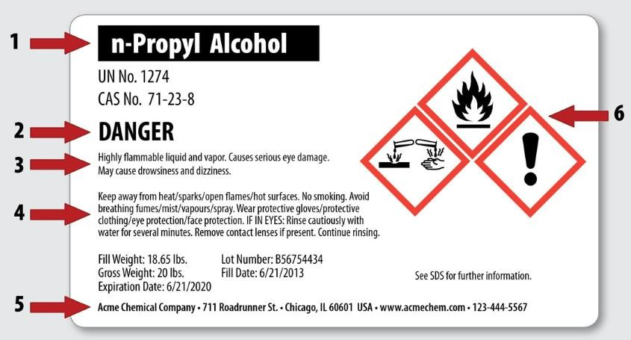

**Butyl Alcohol**

### Figure 3.1

* 1. What is the main purpose of the GHS label?
  2. Which portion (indicated as**1, 2, 3, 4, 5**, and **6** in Figure 3.1) is the “Hazard Statements”?
  3. We can “*See SDS for further information*” as stated in the GHS label above, except the information stated in the GHS label above, state **TWO** (2) other information that can be found in SDS.

## END OF QUESTION 3

**QUESTION 4 [22 Marks]**

As a logistics manager in a hospital, John’s work involved managing the entire hospital’s Medical and Non-medical inventories, from procurement of the inventories to disposal when necessary.

He received a recall letter from HSA as shown in Figure 4.1 below:

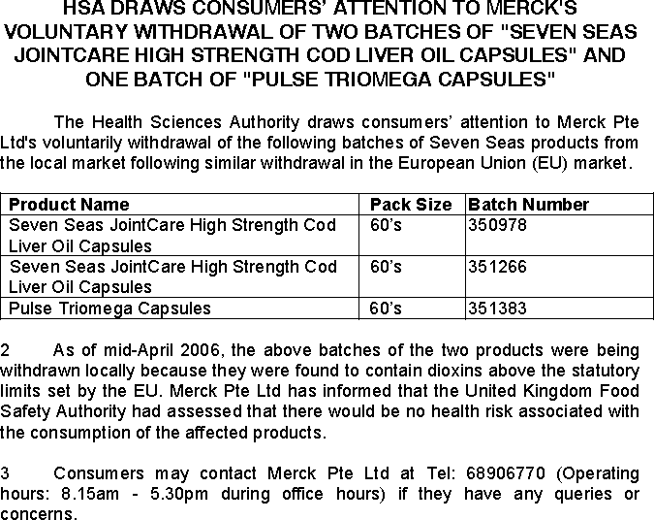

### Figure 4.1

1. Is this recall classified as a Class 1 or Class 2 recall? (2 marks)
2. What is the level of recall initiated in this case? (2 marks)
3. Can a recalled product be returned to market for sale? **Explain**. (2 marks)
4. For the purpose of recall, what is the minimum duration that sales record needs to be maintained? (2 marks)
5. Identify **TWO (2)** forms that are required to be completed and submitted to HSA in the event of a recall. (2 marks)
6. John also needs to ensure smooth operations of the clearance of the bio-waste to an off-site location. Where will usually this location be? Suggest **THREE** (**3)** reasons why off-site treatment of bio-waste is preferred in Singapore.

(4 marks)

1. John enforced all users of the consumables to go through proper PO requisition. Why is this important to the hospital?

(2 marks)

1. An alternative method of disposal is to autoclave the wastes before disposal. Describe the autoclaving process.

(3 marks)

1. In a clinical trial, all the staff in the hospital pharmacy is trained to identify the authenticity of the clinical trial products’ covert features on the packaging of the products. State at least **THREE** (3) possible features the staff would likely to identify on the packaging of pharmaceutical products.

(3 marks)

# QUESTION 5 [10 Marks]

1. You are an intern with MedicTek Pte Ltd, a local distributor for medical supplies. The company recently acquired a dealership of a well-known Japanese brand contact lenses, and will start to supply the contact lenses in Singapore at the end of 1st quarter 2017. Your supervisor at MedicTek instructed you to understand the supply chain process of the contact lenses.

Under which **authority** and **regulation** Medictek has to comply with in order to carry out the import, storage, handling, as well as the supply operations of the contact lenses in Singapore? (2 marks)

1. MedicTek is planning to bring in a medical device X into Singapore from the United States. Your supervisor asked you to find out the classification of this medical device X and registration process according to Health Science Authority (HSA) medical device classification rules. The only information you have is that medical device X is not a class A medical device.

What are the guidances that you can refer to in order to determine the class of the medical device X AND if the product registration is required? (3 marks)

1. The following Table 5.1 shows the route of application and total fees incurred on the registration of 9 medical devices. Determine the class of these medical devices by filling up the blanks denoted as (x), (y) and (z). Note: none of these items are identical. (3 marks)

### Table 5.1

|  |  |  |  |
| --- | --- | --- | --- |
| **Devices** | **TAT for Registration Routes** | **Total Fees** | **Risk Classification** |
| 1)Device ABC 2)Device BCD 3)Device CDE | Abridged | $6,900 | (x) (1 mark) |
| 4)Device JKL 5)Device KLM | Full | $23,800 | (y) (1 mark) |
| 6)Device PQR 7)Device QRS 8)Device RST 9)Device STU | Expedited | $14,000 | (z) (1 mark) |

1. Under the regulatory framework of HSA, starting from January 2013, the licensing for dealers to import and manage only Class A medical devices would not require the dealers to be GDPMDS certified. However, what would be required for these dealers to comply with as stipulated by the regulatory framework of HSA? (2 marks)

### END OF PAPER